SHIELDING ANALYSES OF THE LATIN AMERICAN CASK FOR TRANSPORTATION AND INTERIM STORAGE OF SPENT FUEL FROM RESEARCH REACTORS

Hugo Moura Dalle

Centro de Desenvolvimento da Tecnologia Nuclear – CDTN/CNEN
Caixa Postal 941 – Cidade Universitária – Pampulha
30123-970 – Belo Horizonte/MG – Brazil

ABSTRACT

This report presents the shielding calculations carried out for the Latin American interim storage and transportation cask. Such cask is being designed for the spent fuel elements of research reactors in the region. The SCALE4.4A package is utilized in the analyses.

Key Words: Shielding, SCALE4.4A, Cask, Spent Fuel, Research Reactors

1. INTRODUCTION

In 2001, the International Atomic Energy Agency – IAEA – started the coordination of the project RLA/4/018. This project, named Management of Spent Fuel from Research Reactors, has supported a joint effort of Latin American research reactors operators in Argentina, Brazil, Chile, Mexico, and Peru to accomplish with the objective on to “define the basic conditions for a regional strategy for managing spent fuel which will provide solutions that are in the economic and technological realities of the countries involved, and in particular, to determine what is needed for the temporary wet and dry storage of spent fuel from the research reactors in the countries of the Latin American region and to establish forms of regional cooperation for storage of the spent fuel or its derivatives”.

Such work get considerable importance since the USA spent fuel take-back program will be a finished option in May, 2006. After that the Latin American research reactors operators will need to identify and assess all possible options which could be implemented to deal with their spent fuel by themselves.

Part of the project consists in to design a cask for interim storage and transportation of the spent fuel produced by these research reactors. In Latin America there are two main types of research reactors under operation: TRIGA and MTR reactors. Such concern is being taken in to account in the cask design that must be suitable for the different fuel elements used in these reactors.

The shielding analyses of the cask was carried out with SCALE4.4A [1]. The SCALE package is a codes system for licensing purposes well known and very used for criticality safety, source terms determination, shielding and Heatload analyses of similar casks manufactured by different vendors around the world.

2. DESIGN CRITERIA

The maximum dose values [2, 3] at the highest intensity point must be, for the sum of the gamma and neutron dose rates, lower than:

- 10000 μSv/h (1 Rem/h) - Local dose rate on the surface of the cask which can be easily touched during transport under exclusive use.

- 2000 μSv/h (0.2 Rem/h) - Local dose rate on the surface of the vehicle/carriage which can be easily touched.

- 100 μSv/h (0.01 Rem/h) - Local dose rate 2 meters away from the surface of the vehicle/carriage which can be easily touched.

- 20 μSv/h (0.002 Rem/h) - Local dose rate at each of the normally occupied parts of the vehicle/carriage if no personal dose meters is used, whereby no evidence is furnished for this limit value, which means that the use of personal dose meters is necessary for persons accompanying the transport.

- 10000 μSv/h (1 Rem/h) - Local dose rate 1 meter away from the cask surface after the Type B(U) tests of resistance in accidents during transport.

3. CASK GEOMETRY AND MATERIAL MODELING

The geometry and material modeling of the cask follows the characteristics showed in the figure 1. All dimensions in the figure are in millimeters. The cask has an inner and an outer shell (liner) made with stainless steel 304. A lead shield in between the shells completes the model.

Dimensions used in the calculations are as figure 1 and no component tolerances are taken in to account. It means that these dimensions shall be the minimum accepted for manufacturing process. Due to the different types of fuel elements used in the region many baskets shall be designed. Currently, the calculations were performed considering only two types of basket, both made with SS304. One for MTR elements, which hosts 21 fuel elements and another basket for TRIGA with 78 locations. The geometry data of the TRIGA basket are shown in figure 2.

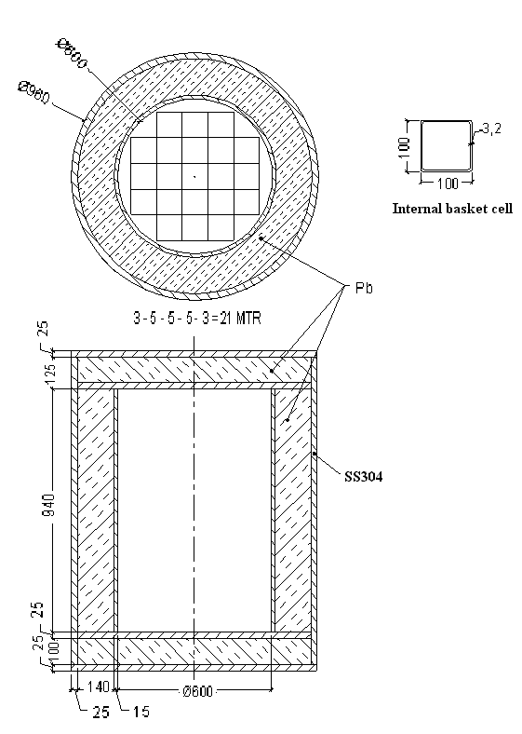

Figure 1 – Schematic drawing of the cask with the 21 MTR basket

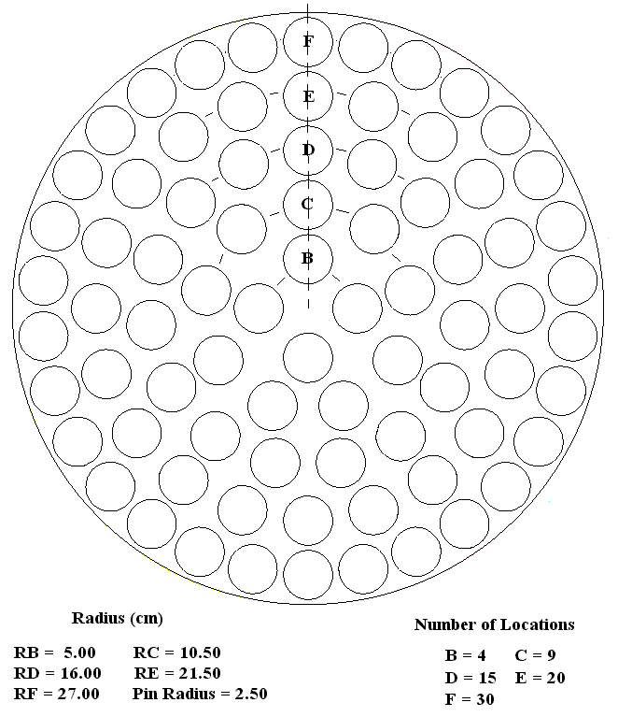

Figure 2 – Schematic drawing of the TRIGA basket

4. RADIATION SOURCE TERMS SPECIFICATION

Two types of radiation sources were determined. The first one refers to the MTR fuel elements, box type. Actually, these fuel elements are the type manufactured by CNEA (Argentinean Atomic Energy Commission) for its RA-3 research reactor [4-6]. The another fuel element type considered is the TRIGA type, indeed the fuel elements used in the TRIGA IPR-R1 reactor [7, 8]. The main characteristics of these two types of fuel elements are summarized in table 1 and 2. Further calculations shall be performed in order to analyze the other specific fuel element types currently used in the other Latin American research reactors. Concerning this purpose the material and geometry data for these fuel elements need to be supplied by the other research reactors operators involved in the project.

The ORIGEN-ARP module of SCALE package was used to determine the gamma and neutron sources. The analyses was based in the ORIGEN-ARP libraries generated during the 2nd Workshop on SCALE, in Lima, Peru (August-2002). The SAS2 module was utilized for producing these data libraries, that are specific for the Peruvian reactor RP-1 (MTR) and IPR-R1 (TRIGA). In spite of the MTR library does not be specific for the RA-3 fuel elements is not expected large errors utilizing it, as the fuel elements of RA-3 and RP-1 are very similar. An ORIGEN-ARP library for RA-3 is being developed in order to check these uncertainties.

Table 1 – Compositions of the Fuel.

Composition | MTR Fuel Elements (RA-3) | TRIGA Fuel Elements (IPR-R1)
Mass of U3O8 (g) | 1743.2 | ----
Mass of HZr (g) | ---- | 2250
Mass of H (g) | ---- | 24.5
Mass of Uranium (g) | 1475.7 | 188
Mass of U235 (g) | 290.7 | 37.2
Mass of Aluminum (g) | 626.1 | ----
Enrichment (% mass) | 19.75 | 19.81
Density (g/cm3) | 4.8 | 6,2

Table 2 - Dimensions and Materials Data

Component | Dimension (cm) | Material
MTR Fuel Plates
Active Zone
Thickness | 0.07 | U308-Al (ρ=4.8 g/cm3)
Width | 6.0 | U308-Al
Height | 61.5 | U308-Al
Cladding thickness | 0.04 | Aluminum (ρ=2.7 g/cm3)
Plates Height | 65.5 | Aluminum
Others | as figure 1
TRIGA Fuel Elements
Active Zone
Outer diameter | 3.73
Lenght | 72.24
Fuel diameter | 3.56 | U-ZrH (ρ=6.2 g/cm3)
Cladding thickness | 0.076 | Alumínio (ρ=2.7 g/cm3)
Fuel Height | 35.56
Axial reflectors | 10.16 | Graphite (ρ=1.7 g/cm3)
Others | as figure 2

The gamma and neutron sources were estimated considering a burnup of 50% (U235 depleted) and 25% for MTR and TRIGA fuel, respectively. Furthermore, a 5 (five) years decay time (cooling time) was adopted in the model.

The gamma and neutron spectra as well as the source strengths can be seen in table 3. Those values are per fuel element, it means that in order to get the total source strength inside the cask the values in the table 3 must be multiplied by the number of fuel elements. The energy group structure for neutrons and gamma are as the 27N-18COUPLE SCALE library.

Gamma with low energy, which are strongly shielded, are the majority and the high energy gamma are just a few. It is a favorable condition from shielding point of view. The same is observed for neutrons. The gamma and neutron source intensity is assumed flattened over the entire fuel element active length (that is a short length). Due to the weak neutron source intensity, after five years cooling time, no neutron-induced gamma radiation is assumed. Neutron source considers the contribution of spontaneous fission neutrons and neutrons from the α-n reactions in the oxygen of the fuel.

Table 3 – Neutron and Gamma Source for RA-3 (MTR box) and IPR-R1 (TRIGA) Fuel

Energy (MeV) | Gamma (photons/s/element) |  | Energy (MeV) | Neutrons (neutrons/s/element)
 | MTR | TRIGA |  | MTR | TRIGA
10.0 to 8.0 | 2.8249E+00 | 1.0 | 20.0 to 6.43 | 8.018E+01 | 1.342E+00
8.0 to 6.5 | 1.3357E+01 | 1.0 | 6.43 to 3.0 | 1.263E+03 | 2.563E+01
6.5 to 5.0 | 6.8483E+01 | 1.3068E+00 | 3.0 to 1.85 | 2.004E+03 | 4.627E+01
5.0 to 4.0 | 1.7173E+02 | 3.2915E+00 | 1.85 to 1.40 | 8.357E+02 | 1.735E+01
4.0 to 3.0 | 2.9648E+07 | 6.1579E+05 | 1.40 to 0.90 | 9.196E+02 | 1.725E+01
3.0 to 2.5 | 2.6175E+08 | 5.4300E+06 | 0.90 to 0.40 | 8.828E+02 | 1.530E+01
2.5 to 2.0 | 3.3792E+10 | 6.9080E+08 | 0.40 to 0.10 | 1.711E+02 | 2.949E+00
2.0 to 1.66 | 5.6799E+09 | 1.5103E+08
1.66 to 1.33 | 7.3329E+10 | 1.6087E+09
1.33 to 1.0 | 1.8011E+11 | 5.0044E+09
1.0 to 0.8 | 7.4752E+11 | 1.4928E+10
0.8 to 0.6 | 1.2597E+13 | 6.8141E+11
0.6 to 0.4 | 2.0304E+12 | 4.7645E+10
0.4 to 0.3 | 5.4545E+11 | 2.4711E+10
0.3 to 0.2 | 7.3889E+11 | 3.3934E+10
0.2 to 0.1 | 2.6894E+12 | 1.1497E+11
0.1 to 0.05 | 3.3567E+12 | 1.5790E+11
0.05 to 0.01 | 1.1223E+13 | 5.3731E+11
Total | 3.4221E+13 | 1.6203E+12 | Total | 6.157E+03 | 1.261E+02

5. CALCULATION METHOD

The shielding analyses was performed using the SCALE4.4A package. The module ORIGEN-ARP was used to determine the radioactive, neutron and gamma, source as described in section 4. For shielding calculation itself two SCALE modules were utilized, being QADS and SAS4.

QADS calculation enabled a preliminary estimation of the local gamma dose rates. The program uses the point kernel technique to perform the estimation of gamma transport through the shielding materials. In this method, a point kernel representing the transfer of energy by the uncollided flux along a line-of-sight path is combined with an appropriate buildup factor to account for the contribution from scattered photons. Energy dependent mass attenuation coefficients and the dose build-up factors are enclosed in the code. The gamma flux conversion in dose rates is performed with the Gamma Ray Flux-to-Dose Rate Factors ANSI/ANS-6.1.1, 1977. The code allows a three-dimensional source and shielding geometry description of the problems.

Neutron and more detailed gamma dose rates calculations were performed with SAS4. The Shielding Analysis Sequence No. 4 (SAS4) control module performs a three-dimensional (3-D) Monte Carlo shielding analysis of a nuclear fuel transport or storage cask using an automated biasing procedure. In a Monte Carlo shielding analysis of a deep-penetration problem such as a spent fuel cask, variance reduction techniques must be used to calculate reasonably good results at an affordable cost. Generation of biasing parameters and application of the parameters to solve a particular problem are no trivial tasks. Nevertheless, a systematic approach has been developed for biasing a Monte Carlo transport calculation of a spent fuel cask. This approach uses adjoint fluxes from a one-dimensional (1-D) discrete-ordinates calculation performed with the XSDRNPM code to generate the biasing parameters for a Monte Carlo analysis by the MORSE-SGC code The entire procedure for cross-section preparation, adjoint flux calculation, automatic generation of Monte Carlo biasing parameters, and a Monte Carlo calculation has been implemented in this control module to provide calculated radiation dose levels exterior to a cask at a reasonable computational cost. SAS4 computes neutron or gamma dose rates at any user-specified points outside a cask. The response function (dose factor) utilized in these calculation is the Neutron and Gamma Ray Flux-to-Dose Rate Factors ANSI/ANS-6.1.1, 1977.

For the fuel region simulation the homogeneous model IGO=0 was adopted. The cask cavity has 30 cm radius and 94 cm height. However, the active zone of fuel elements have 61.5 cm height and 38.1 cm height, respectively, for MTR and TRIGA fuel elements. Therefore, the model assumes conservatively two void zones in the bottom and top of the cask cavity due to the negligible activation of the Aluminum end fittings of the fuel elements. No radial void is assumed.

In the model, the basket is represented as a homogeneous cylindrical source zone with 30 cm radius and 61.5 cm height (for MTR) or 38.1 cm height (for TRIGA). The source material fulfilling the source zone is modeled having one third of the fuel density and the concentration of heavy metal (Uranium) in the fuel is reduced by the same factor in order to conservatively reduce the self-shielding of the source.

6. RESULTS

The shielding calculations results are summarized in tables 4, 5 and 6. They present the dose values at the highest intensity point at cask outermost side wall and bottom as well as at 1 m and 2 m away from the cask surfaces. Results shown in table 4 were obtained using QADS and refer to MTR21 basket. Table 5 presents Monte Carlo results (SAS4) for gamma and neutrons. The neutron dose contribution to the total dose rates are not significant. The main contribution comes from gamma radiation as the analyses was carried out considering a five years cooling time.

The strength of the TRIGA source is lower than the MTR source by a factor around 20 (see table 3). It leads to a simpler shielding analyses of the TRIGA basket, then only the SAS4 analyses was performed and the results can be seen in table 6.

Table 4 – QADS Dose Rates for Basket with RA-3 Fuel (MTR box)

 |  |  | Side Dose Rate (μSv/h)
 |  |  | Distance (m) | Distance (m) | Distance (m)
Case |  |  | 0 | 1 | 2
G_qads21 |  | Gamma | 83.40 | 22.23 | 8.67
 |  |  | Top/Bottom Dose Rate (μSv/h)
 |  |  | Distance (m) | Distance (m) | Distance (m)
Case |  |  | 0 | 1 | 2
G_qads21 | Gamma |  | 769.47 | 165.53 | 56.54
A comparison between the values presented in tables 4 and 5 show large differences. One of the reasons for that is surely the restriction for using just one buildup factor in the QADS calculation. In spite of QADS be able to model the cask representing their components and shielding materials (lead and stainless steel) in a manner geometrically accurate, the code offers just one option of buildup factor. The results presented in table 4 were gotten using the buildup factor of Lead, which is the main shielding material – previous experience has shown that just changing the buildup factor from Lead to Iron the dose rates increase by a factor around 2.5.

Table 5 – SAS4 Dose Rates for Basket with RA-3 Fuel (MTR box)

 |  |  | Side Dose Rate (μSv/h)
 |  |  | Distance (m) | Distance (m) | Distance (m)
Case |  | Source | 0 | 1 | 2
N_rad_21 |  | Neutron | 4.33 | 0.39 | 0.13
G_rad_21 |  | Gamma | 229.13 | 30.29 | 10.37
 |  | Total | 233.5 | 30.7 | 10.5
 |  |  | Top/Bottom Dose Rate (μSv/h)
 |  |  | Distance (m) | Distance (m) | Distance (m)
Case | Source |  | 0 | 1 | 2
N_bot_21 | Neutron |  | 4.39 | 0.31 | 0.09
G_bot_21 | Gamma |  | 1515 | 240.5 | 72.35
 | Total |  | 1519.4 | 240.8 | 72.4

Table 6 – SAS4 Dose Rates for Basket with IPR-R1 Fuel (TRIGA)

 |  |  | Side Dose Rate (μSv/h)
 |  |  | Distance (m) | Distance (m) | Distance (m)
Case |  | Source | 0 | 1 | 2
N_rad_78 |  | Neutron | 0.08 | 0.006 | 0.002
G_rad_78 |  | Gamma | 22.3 | 2.17 | 0.8
 |  | Total | 22.4 | 2.2 | 0.8
 |  |  | Top/Bottom Dose Rate (μSv/h)
 |  |  | Distance (m) | Distance (m) | Distance (m)
Case | Source |  | 0 | 1 | 2
N_bot_78 | Neutron |  | 0.08 | 0.005 | 0.002
G_bot_78 | Gamma |  | 111.2 | 21.1 | 7.2
 | Total |  | 111.3 | 21.1 | 7.2

The highest dose rates occur at the top (or bottom) surface of the cask. In any case such values are bellow the limit mentioned in section 2 regarding the criteria number (i) and (iii). Criteria (ii) and (iv) are not clear about the location of the detectors as they depend of the vehicle/carriage. This is a subject that should be discussed during the workshop before to say if the calculated dose rates comply or not with the criteria. Criteria (v) is clear and concerns about the type B tests and any comments should be made after the tests, however, if the tests prove the integrity of the cask under conditions of accidents during transportation the results already show compliance.

7. CONCLUSIONS

The highest dose rates occur at the top (or bottom) surface of the cask. The dose rates for TRIGA basket are well bellow the values of the MTR basket. In any case such values are bellow the limit regarding the criteria number (i) and (iii). Criteria (ii) and (iv) are not clear about the location of the detectors as they depend of the vehicle/carriage. This is a subject that should be discussed during the workshop before to say if the calculated dose rates comply or not with the criteria. Criteria (v) is clear and concerns about the type B tests and any comments should be made after the tests, however, if the tests prove the integrity of the cask under conditions of accidents during transportation the results already show compliance.

8. REFERENCES

[ 1] Oak Ridge National Laboratory. SCALE4.4A Eletronic Manual. ORNL/RSICC, 2000.

[ 2] Safety Series Nº 6. Regulations for the Safe Transport of Radioactive Materials. International Atomic Energy Agency Vienna, 1985.

[ 3] Safety Series Nº 37. Advisory Material for the IAEA Regulations for the Safe Transport of Radioactive Materials. International Atomic Energy Agency Vienna, 1985.

[ 4] Medina E. G., Nassini H. E., Informe de Diseno en Condiciones Normales de Operacion de los Elementos Combustibles de Bajo Enriquecimiento (ECBE) Normal y de Control Destinados al RA-3. CNEA, UPESN, IT-IEC 02/90, Argentina.

[ 5] Perez E. E., Descripción del Prototipo ECBE de 19 Placas Combustibles para Irradiacion en el RA-3. CNEA, Departamento Combustibles Nucleares, Argentina.

[ 6] Personal communication of Mr. Jorge Quintana from Centro Atômico Ezeiza, Argentina, at IPEN/CNEN, May of 2002, São Paulo, Brazil.

[ 7] Dalle H. M., Cálculo Neutrônico do Reator Triga IPR – R1 Utilizando WIMSD4 e Citation. Dissertação de Mestrado, UFMG, 1999, Belo Horizonte, Brazil.

[ 8] Dalle, H. M., Pereira, C., Souza, R. G. P. Neutronic calculation to the TRIGA IPR-R1 Reactor using the WIMSD4 and CITATION codes. Annals of Nuclear Energy, Vol 29, Aug 2002 pp. 901-912.

